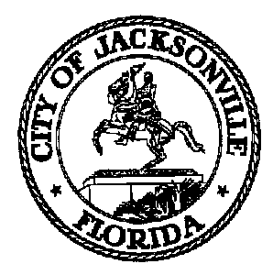
Taxation, Revenue and Utilization of
Expenditures (TRUE) Commission

Daniel Henry, Chair TRUE Commission
c/o Jeff Clements
Suite 425, City Hall
117 W. Duval Street
Jacksonville FL 32202
904-255-5137

TO: TRUE Commissioners

FR: Daniel Henry – Chair

RE: January 13, 2022 TRUE Commission Meeting Notice

The TRUE Commission monthly meeting originally scheduled for Thursday, January 6, 2022 has been RESCHEDULED to Thursday, January 13, 2022 at 4:00 p.m. in the Don Davis Room, 1st floor, City Hall.

Pursuant to the American with Disabilities Act, accommodations for persons with disabilities are available upon request. Please allow 1-2 business days’ notification to process; last minute requests will be accepted but may not be possible to fulfill. Please contact the Disabled Services Division at: 904-255-5466 or 904-255-5476, or email your request to KaraT@coj.net.

You may attend the meeting in-person at the physical location - Don Davis Room - but CDC guidelines will be adhered to due to COVID-19. Concurrent with the expiration of Mayor Curry's Emergency Executive Proclamation 2020-005, any member of the public entering City-owned public buildings may choose to wear a mask inside the building. Council strongly encourages the use of masks for all employees and visitors, especially when social distancing at 6 feet (or more) is not possible. Masks will be made available for members and the public.

For further information contact Jeff Clements at jeffc@coj.net or 904-255-5137.

Jeff Clements, Council Research Division Posted 1.4.22 9:30 a.m.

